Docker Final Task

Goal of the Exercise
The goal of this exercise is to test your understanding of a Cloud Compute deployment with Terraform.
You are tasked with creating a codebase for a microservice deployment on a cloud environment, using Terraform. Since our focus is not the application itself, the service will be a simple web server that returns a static page.
Requirements
Service Details
The service will be a simple web server that returns a static page.
You can use apache2 or nginx to serve a simple HTML file.
The service should be containerized and stored in a Docker registry.
The service should be deployed on a single VM instance as a docker container.
The image should be pulled from the registry specified earlier.
- The service should not be accessible from the internet but only through a Load Balancer, except for SSH access from specific IP addresses.
Deliverables
You are to provide the following as part of your solution:
- Dockerfile to build the image.
- Terraform codebase to deploy the following:
- Docker registry
- VPC and all required networking resources
- EC2 instance
- Load Balancer
Notes
Since a CI/CD pipeline is not part of this exercise, we will work around that with the help of Terraform.
To push the image to the Docker registry, build the image locally before running the Terraform code.
Once the image registry is created, use Terraform to push the local image to the registry.
Similarly, use Terraform to pull the image from the registry and run it on the VM instance once it is created.
For SSH access:
Use a locally created key.
Add it to the cloud provider key storage.
Attach it to the instance.
Use Terraform best practices for file structure and code organization.
Use variables, locals, modules, etc. when appropriate.
Include all tfvars, scripts, and other helper files used to deploy the application.
You may use any cloud provider of your choosing, although AWS is preferred.
- Use a free tier account or a trial account to deploy the resources.

STEP-BY-STEP CLOUD MICROservice DEPLOYMENT
(Docker + Terraform + AWS)

STEP 0 – Prerequisites (Local Machine)
Make sure you have:
aws --version
terraform --version
docker --version
Also:
- AWS Free Tier account
- IAM user with AdministratorAccess
- AWS CLI configured
aws configure

STEP 1 – Create the Working Tree (IMPORTANT)
Create the project folder:
To Create above working tree directories and files we will execute below command or else we can create manually but the processes is time consuming so that we will create using below command.

mkdir -p terraform-microservice/{docker,terraform} && \
touch terraform-microservice/docker/{Dockerfile,index.html} && \
touch terraform-microservice/terraform/{provider.tf,variables.tf,terraform.tfvars,vpc.tf,security.tf,ecr.tf,iam.tf,ec2.tf,alb.tf,userdata.sh,outputs.tf} && \
touch terraform-microservice/README.md
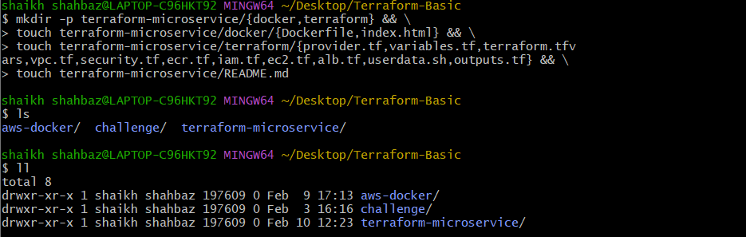
cd terraform-microservices/
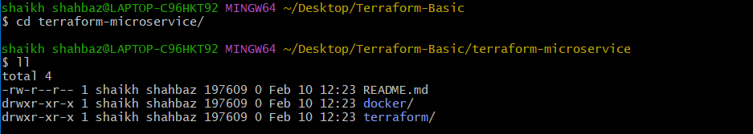
cd docker/
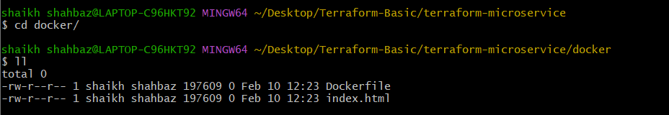
cd terraform/
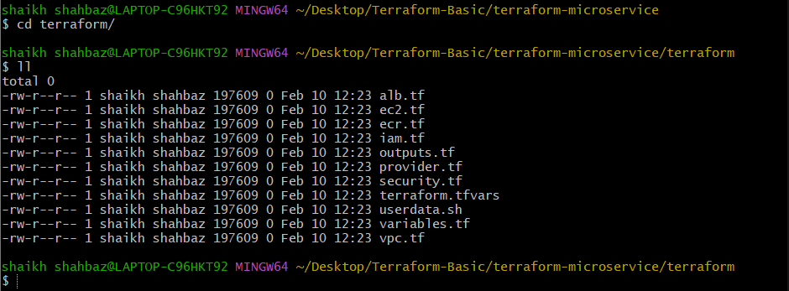

Final Working Tree (REFERENCE)
terraform-microservice/
│
├── docker/
│ ├── Dockerfile
│ └── index.html
│
├── terraform/
│ ├── provider.tf
│ ├── variables.tf
│ ├── terraform.tfvars
│ ├── vpc.tf
│ ├── security.tf
│ ├── ecr.tf
│ ├── iam.tf
│ ├── ec2.tf
│ ├── alb.tf
│ ├── userdata.sh
│ ├── outputs.tf
│
└── README.md

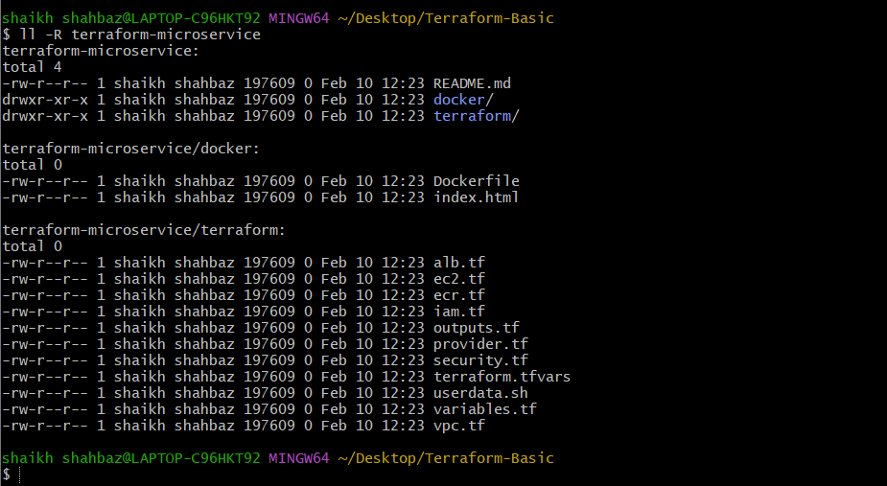

STEP 2 – Create the Docker Application
docker/index.html
<!DOCTYPE html>
<html>
<head>
<title>Terraform Microservice By Shahbazz</title>
</head>
<body>
<h1>Hello from Shahbazz ---- Terraform + Docker 🚀</h1>
<p>This is a simple static web service.</p>
<p>Deployed as a Docker container on a cloud VM.</p>
</body>
</html>

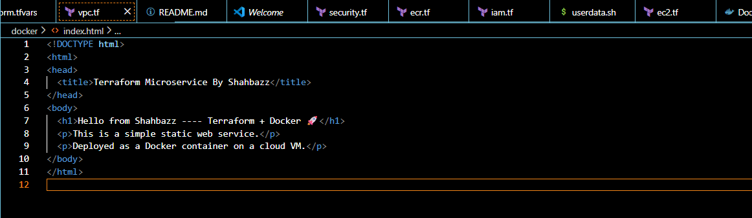

docker/Dockerfile

FROM nginx:alpine

COPY index.html /usr/share/nginx/html/index.html

EXPOSE 80

✔ This creates a static web server using NGINX.

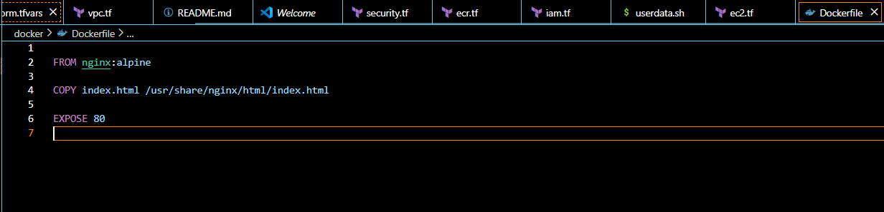

STEP 3 – Terraform Provider Configuration
terraform/provider.tf
terraform {
required_providers {
aws = {
source = "hashicorp/aws"
version = "~> 5.0"
}
}
}

provider "aws" {
region = var.aws_region
}

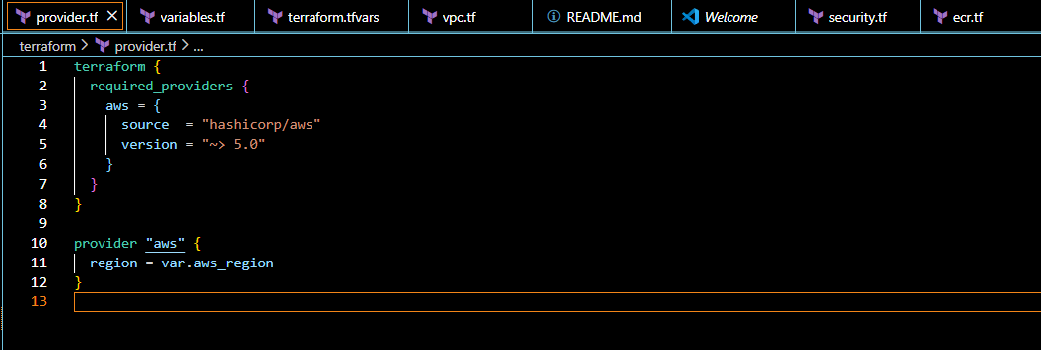

STEP 4 – Terraform Variables
terraform/variables.tf
variable "aws_region" {
default = "us-east-1"
}

variable "project_name" {
default = "terraform-microservice"
}

variable "instance_type" {
default = "t2.micro"
}

variable "ssh_allowed_ip" {
description = "Your public IP with /32"
type = string
}

variable "ecr_repo_name" {
default = "docker-microservices"
}

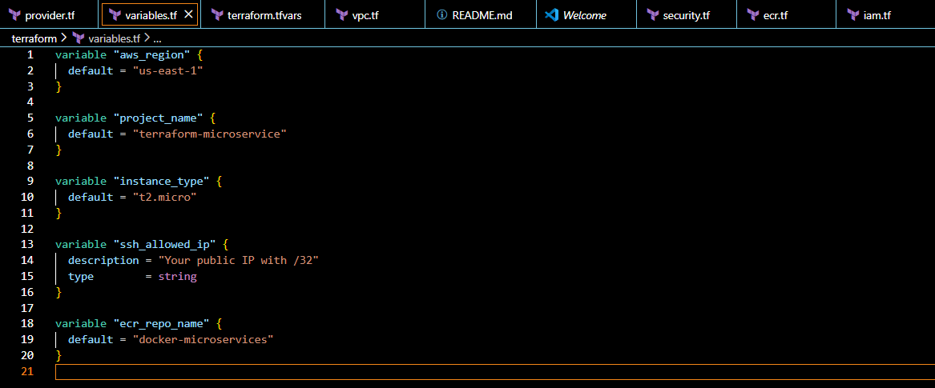

terraform/terraform.tfvars
ssh_allowed_ip = "0.0.0.0/0"
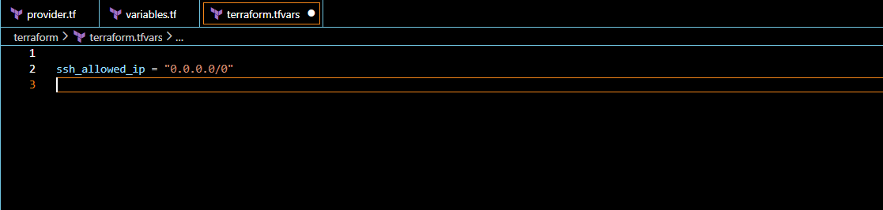
STEP 5 – Create VPC & Networking
terraform/vpc.tf
resource "aws_vpc" "this" {
cidr_block = "10.0.0.0/16"
enable_dns_support = true
enable_dns_hostnames = true
tags = { Name = "tf-vpc" }
}

resource "aws_subnet" "public_1" {
vpc_id = aws_vpc.this.id
cidr_block = "10.0.1.0/24"
availability_zone = "us-east-1a"
map_public_ip_on_launch = true
tags = { Name = "tf-public-1" }
}

resource "aws_subnet" "public_2" {
vpc_id = aws_vpc.this.id
cidr_block = "10.0.2.0/24"
availability_zone = "us-east-1b"
map_public_ip_on_launch = true
tags = { Name = "tf-public-2" }
}

resource "aws_internet_gateway" "igw" {
vpc_id = aws_vpc.this.id
}

resource "aws_route_table" "public" {
vpc_id = aws_vpc.this.id

route {
cidr_block = "0.0.0.0/0"
gateway_id = aws_internet_gateway.igw.id
}
}

resource "aws_route_table_association" "a" {
subnet_id = aws_subnet.public_1.id
route_table_id = aws_route_table.public.id
}

resource "aws_route_table_association" "b" {
subnet_id = aws_subnet.public_2.id
route_table_id = aws_route_table.public.id
}
✔ EC2 will live in private subnet
✔ ALB lives in public subnet

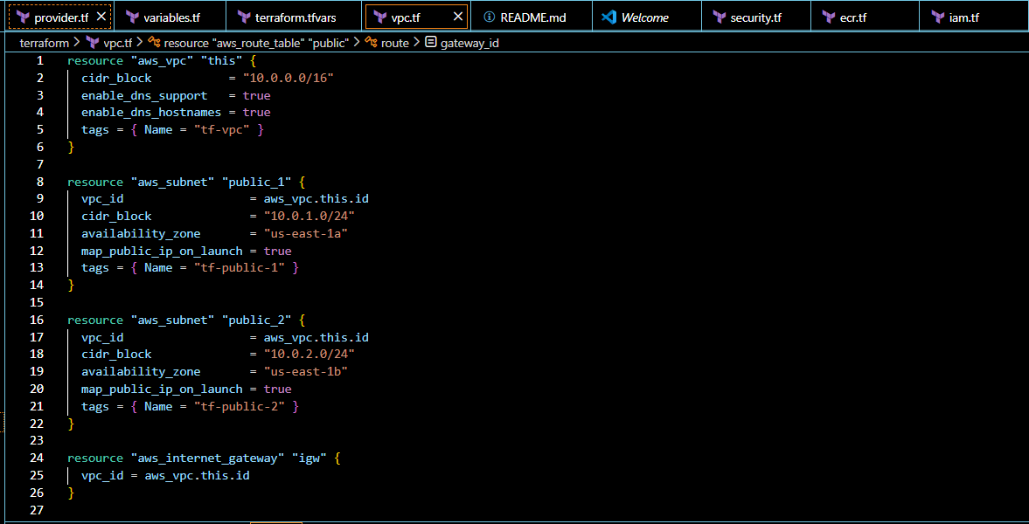

STEP 6 – Security Groups
terraform/security.tf
resource "aws_security_group" "alb_sg" {
vpc_id = aws_vpc.this.id

ingress {
from_port = 80
to_port = 80
protocol = "tcp"
cidr_blocks = ["0.0.0.0/0"]
}

egress {
from_port = 0
to_port = 0
protocol = "-1"
cidr_blocks = ["0.0.0.0/0"]
}
}

resource "aws_security_group" "ec2_sg" {
vpc_id = aws_vpc.this.id

ingress {
from_port = 80
to_port = 80
protocol = "tcp"
security_groups = [aws_security_group.alb_sg.id]
}

ingress {
from_port = 22
to_port = 22
protocol = "tcp"
cidr_blocks = [var.ssh_allowed_ip]
}

egress {
from_port = 0
to_port = 0
protocol = "-1"
cidr_blocks = ["0.0.0.0/0"]
}
}

✔ App only accessible via ALB
✔ SSH allowed only from your IP
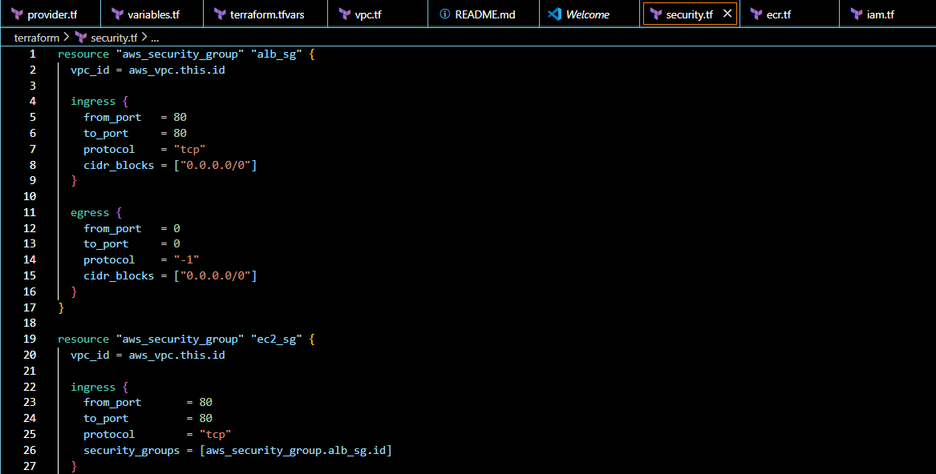

STEP 7 – Create Docker Registry (ECR)
terraform/ecr.tf
########################################
# ECR Repository
########################################
resource "aws_ecr_repository" "app" {
name = "cloud-microservice"
image_tag_mutability = "MUTABLE"

image_scanning_configuration {
scan_on_push = true
}

tags = {
Name = "cloud-microservice-ecr"
}
}

########################################
# Docker Build & Push (Windows Safe)
########################################
resource "null_resource" "docker_push" {

depends_on = [
aws_ecr_repository.app
]

provisioner "local-exec" {
interpreter = ["PowerShell", "-Command"]

command = <<EOT
aws ecr get-login-password --region us-east-1 | docker login --username AWS --password-stdin 444152781336.dkr.ecr.us-east-1.amazonaws.com
docker build -t cloud-microservice ../docker
docker tag cloud-microservice:latest 444152781336.dkr.ecr.us-east-1.amazonaws.com/cloud-microservice:latest
docker push 444152781336.dkr.ecr.us-east-1.amazonaws.com/cloud-microservice:latest
EOT
}
}

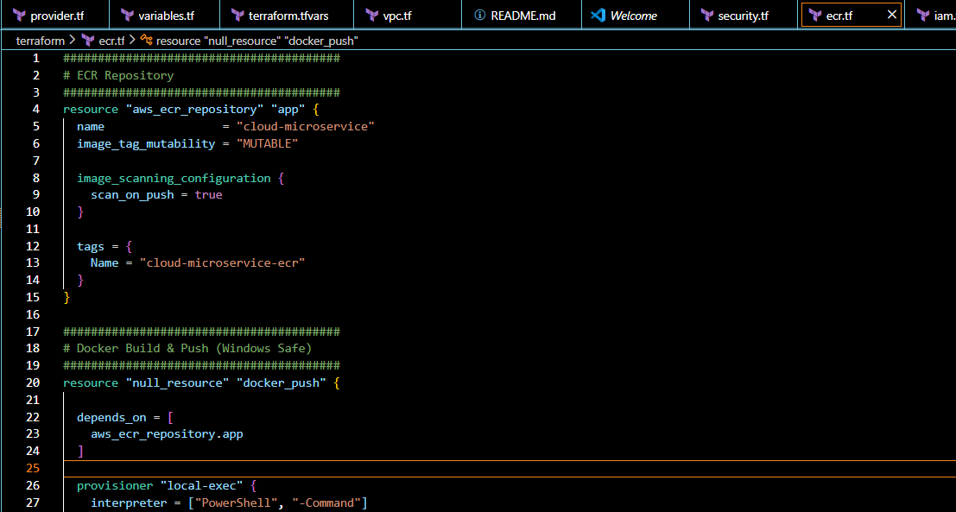

STEP 8 – IAM for EC2 (ECR Pull)
terraform/iam.tf
resource "aws_iam_role" "ec2_role" {
assume_role_policy = jsonencode({
Version = "2012-10-17"
Statement = [{
Effect = "Allow"
Principal = { Service = "ec2.amazonaws.com" }
Action = "sts:AssumeRole"
}]
})
}

resource "aws_iam_role_policy_attachment" "ecr" {
role = aws_iam_role.ec2_role.name
policy_arn = "arn:aws:iam::aws:policy/AmazonEC2ContainerRegistryReadOnly"
}

resource "aws_iam_instance_profile" "this" {
role = aws_iam_role.ec2_role.name
}

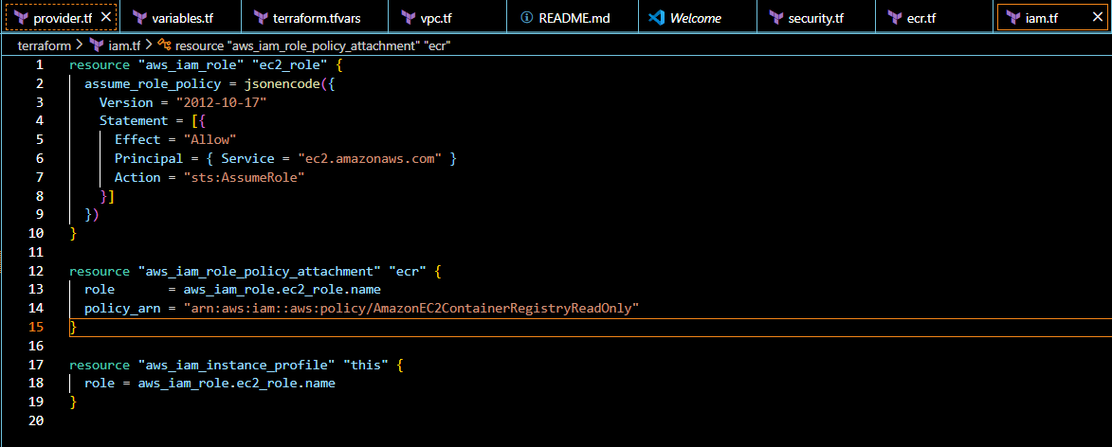

STEP 10 – EC2 Instance & Docker Run
terraform/userdata.sh
#!/bin/bash
set -eux

yum update -y
amazon-linux-extras install docker -y
yum install -y awscli

systemctl start docker
systemctl enable docker

sleep 15

aws ecr get-login-password --region ${AWS_REGION} \
| docker login --username AWS --password-stdin ${ECR_URL}

docker pull ${IMAGE}

docker run -d --restart always -p 80:80 ${IMAGE}

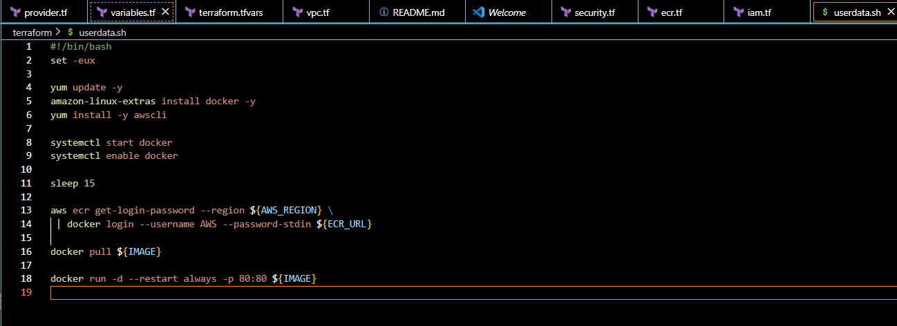

terraform/ec2.tf
data "aws_ami" "amazon_linux" {
most_recent = true
owners = ["amazon"]

filter {
name = "name"
values = ["amzn2-ami-hvm-*-x86_64-gp2"]
}
}

resource "aws_instance" "this" {
ami = data.aws_ami.amazon_linux.id
instance_type = var.instance_type
subnet_id = aws_subnet.public_1.id
vpc_security_group_ids = [aws_security_group.ec2_sg.id]
iam_instance_profile = aws_iam_instance_profile.this.name

user_data = templatefile("${path.module}/userdata.sh", {
AWS_REGION = var.aws_region
ECR_URL = aws_ecr_repository.app.repository_url
IMAGE = "${aws_ecr_repository.app.repository_url}:latest"
})

tags = {
Name = "tf-ec2-app"
}
}

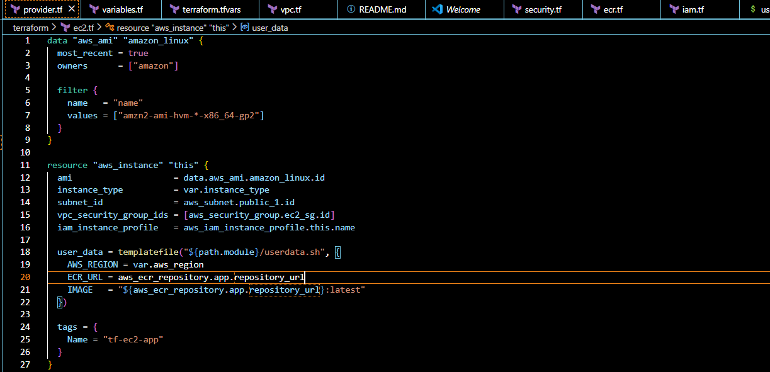

STEP 11 – Load Balancer
terraform/alb.tf
resource "aws_lb" "this" {
name = "tf-alb"
load_balancer_type = "application"
internal = false
subnets = [aws_subnet.public_1.id, aws_subnet.public_2.id]
security_groups = [aws_security_group.alb_sg.id]
}

resource "aws_lb_target_group" "this" {
name = "tf-tg"
port = 80
protocol = "HTTP"
vpc_id = aws_vpc.this.id

health_check {
path = "/"
interval = 30
timeout = 10
healthy_threshold = 2
unhealthy_threshold = 5
matcher = "200"
}
}

resource "aws_lb_listener" "this" {
load_balancer_arn = aws_lb.this.arn
port = 80
protocol = "HTTP"

default_action {
type = "forward"
target_group_arn = aws_lb_target_group.this.arn
}
}

resource "aws_lb_target_group_attachment" "this" {
target_group_arn = aws_lb_target_group.this.arn
target_id = aws_instance.this.id
port = 80
}

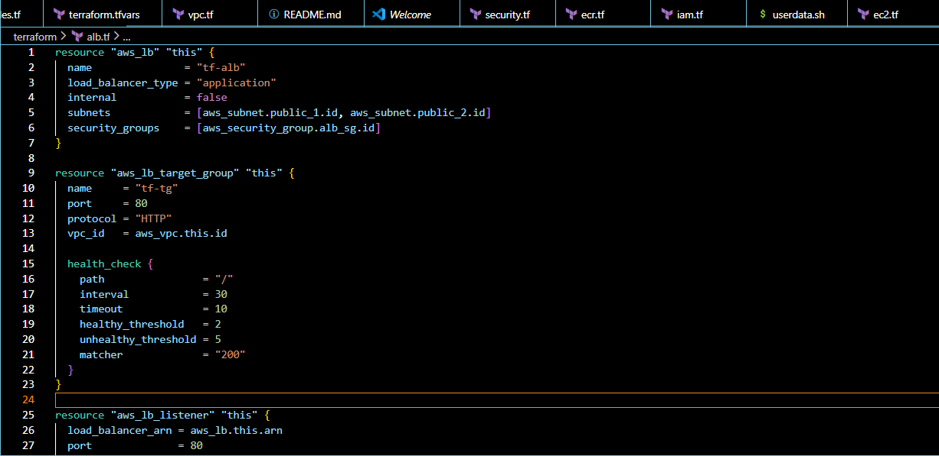

STEP 12 – Outputs
output "alb_dns_name" {
description = "DNS name of the Load Balancer"
value = aws_lb.this.dns_name
}

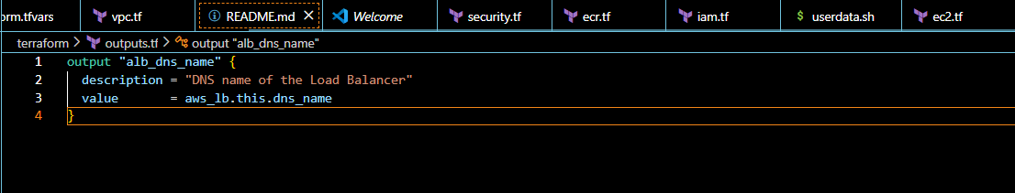

STEP 13 – Terraform Execution
cd terraform
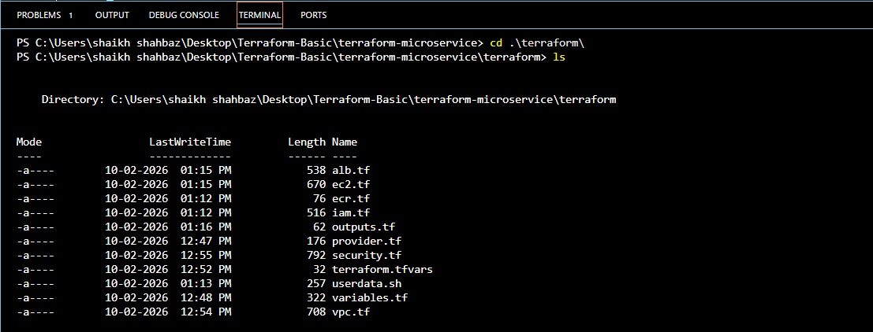
terraform init
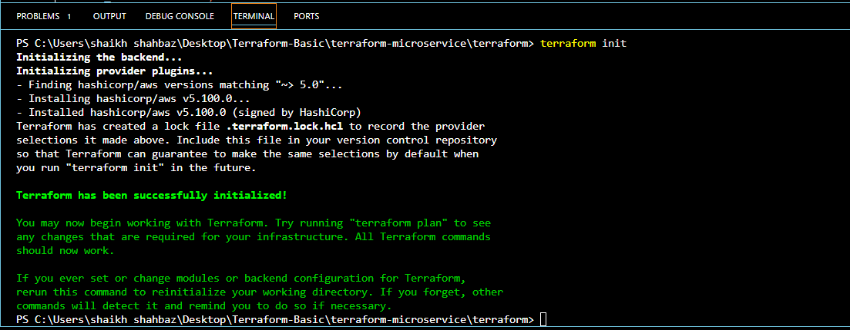
terraform plan
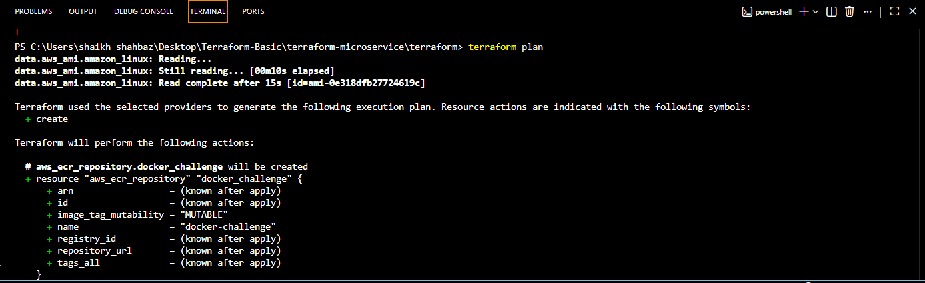
terraform apply
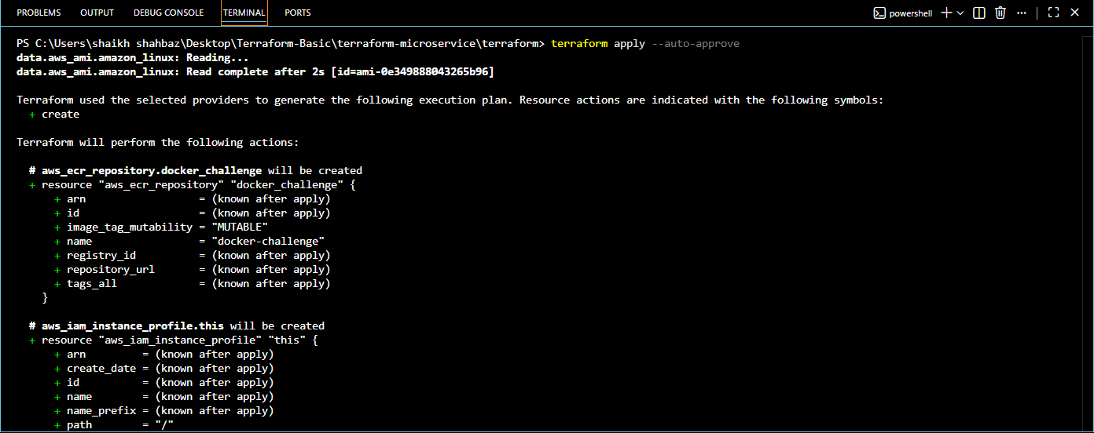
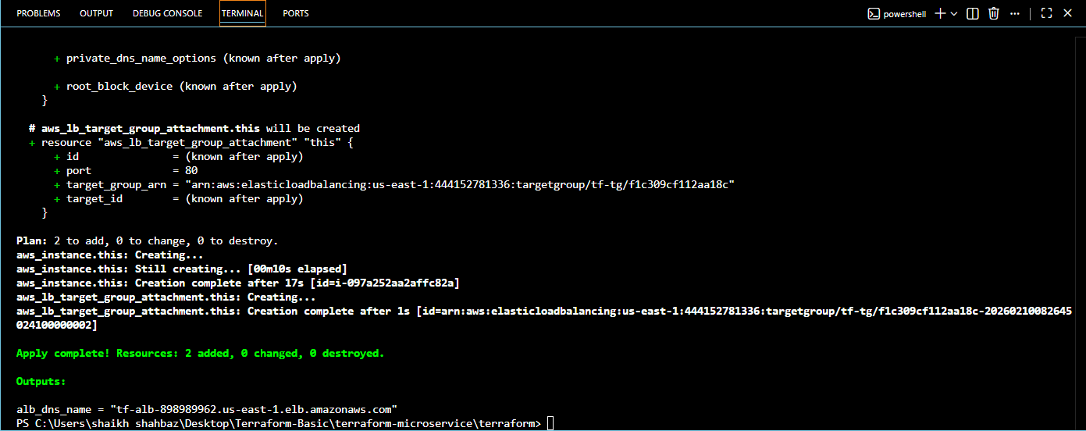

STEP 14 – Access the Application
Terraform output:
tf-alb-334447134.us-east-1.elb.amazonaws.com
Open in browser:
http://<alb_dns_name>

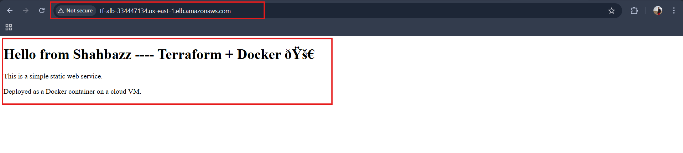

STEP 15 – Final Validation Checklist

✔ Docker image built
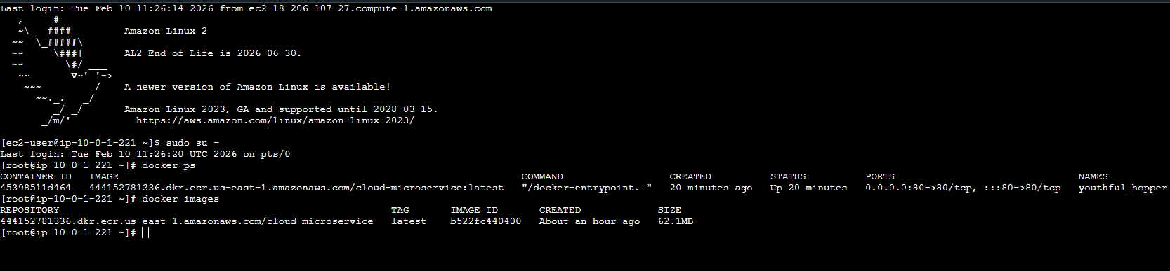

✔ Image pushed to registry
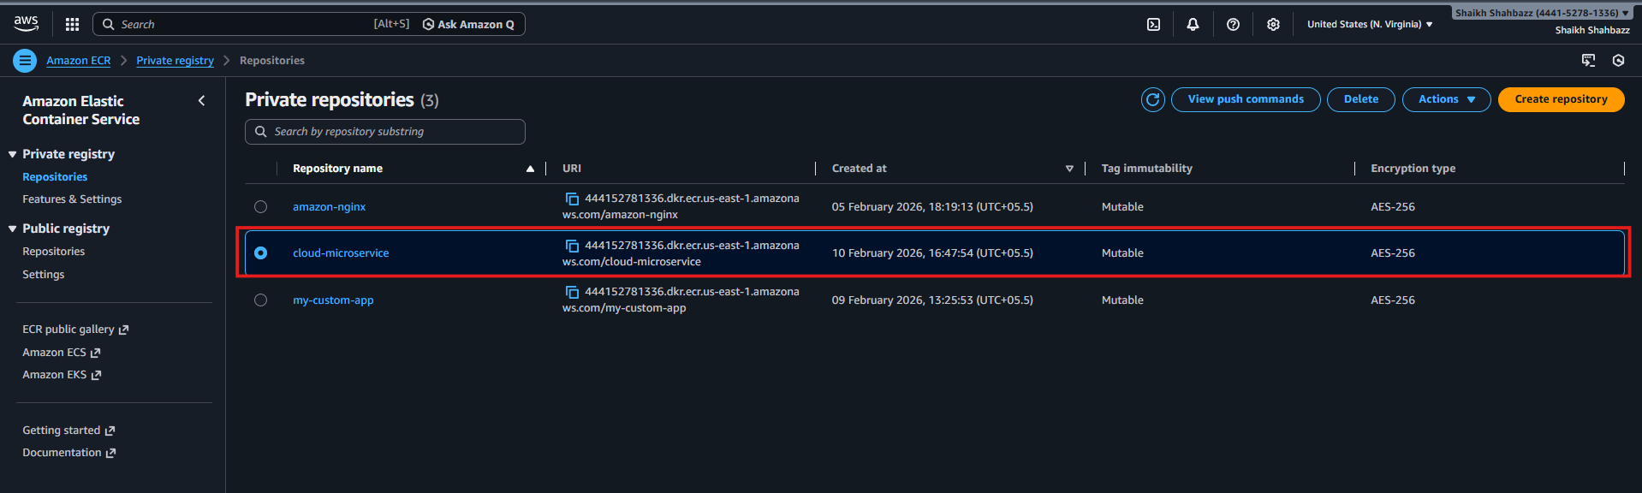

✔ EC2 pulls image via IAM
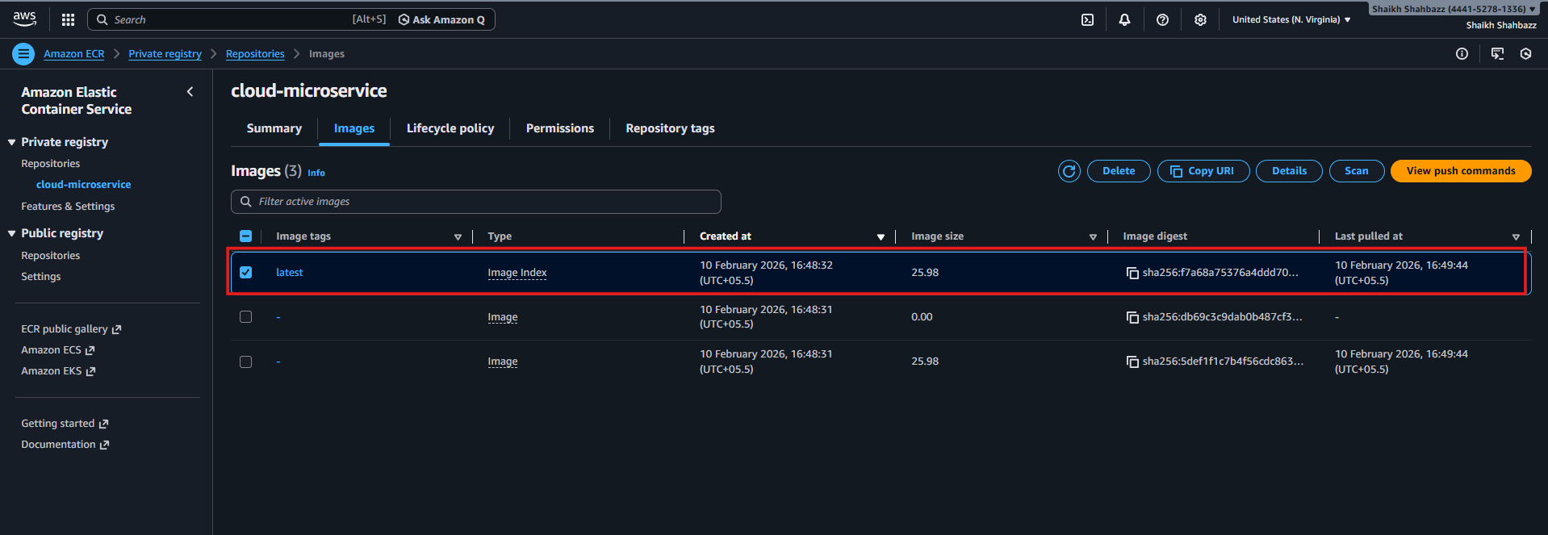

✔ Only ALB accessible
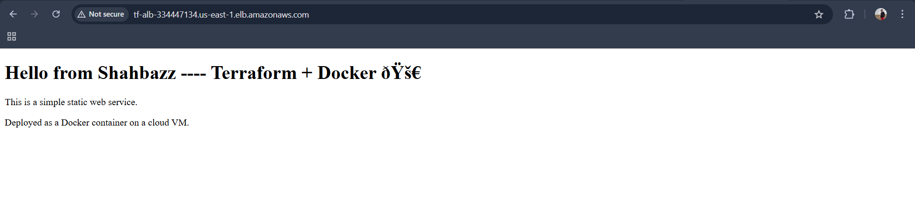

✔ IAM Role : AWSServiceRoleForElasticLoadBalancing
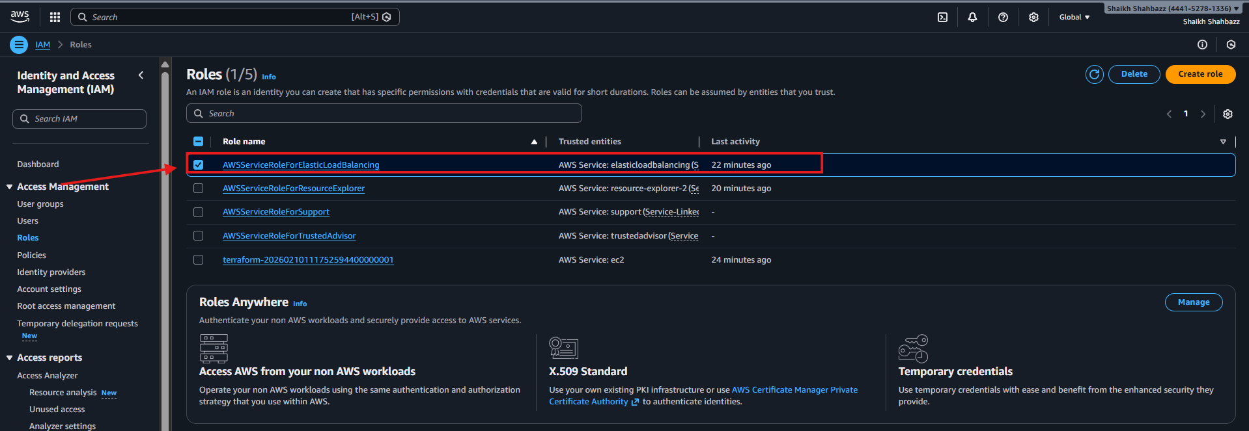

✔ Application Load Balancer :
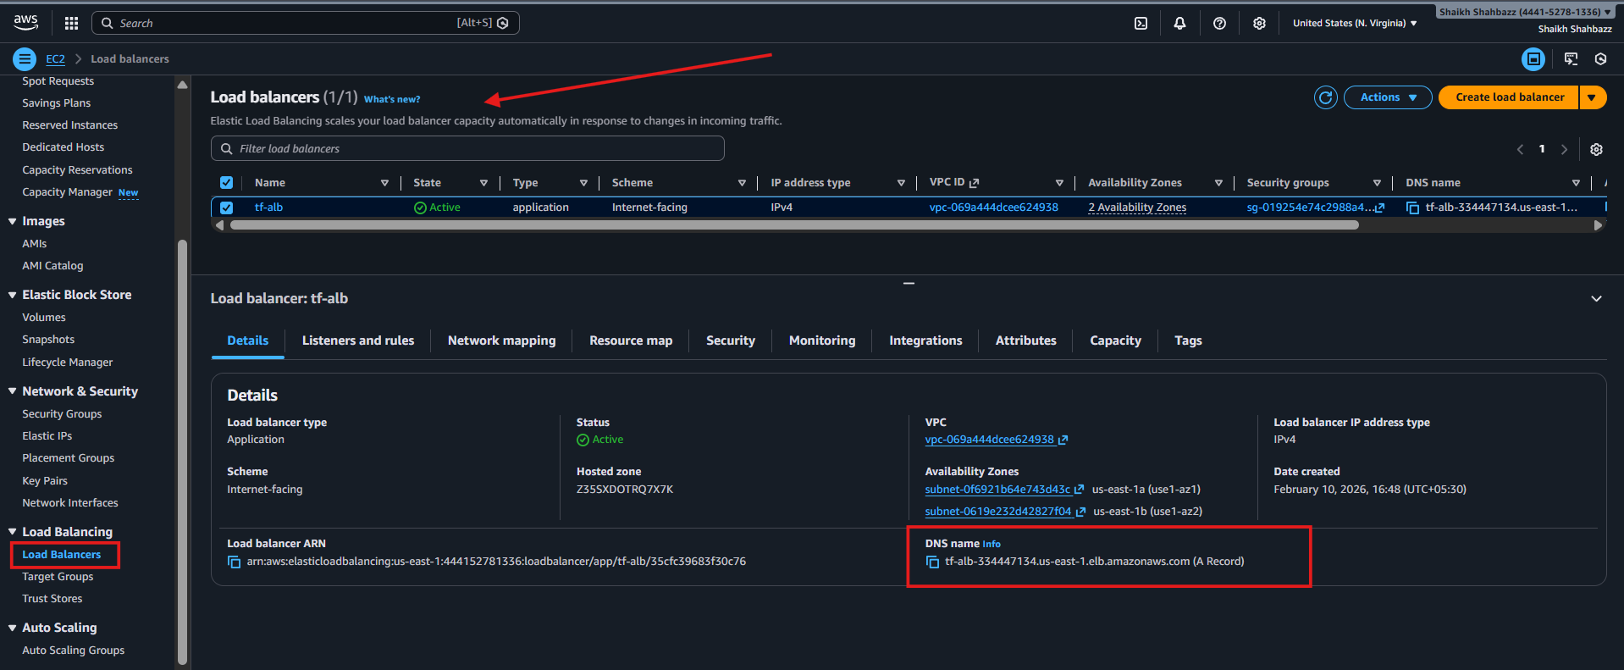

✔ Ec2 instance created with name : tf-ec2-app
